### Statistical Machine Learning Approaches to

### Liver Disease Prediction

**Team ID: PNT2022TMID08311**

**Faculty Mentor Team Leader:** Kavuri Swathi

**T.Geetha Team Member:** Jasthi Jyothi

**TeamMember:** Karumudi Meghana

**TeamMember:**Biridepalli Mounisha

**Run the App**

**Run the application from pycharm**

* Open new pycharm from the start menu
* Navigate to the folder where your python script is.
* Now type “python app.py” command
* It will show the local host where your app is running on **http://127.0.0.1.5000/**
* Copy that local host URL and open that URL in the browser. It does navigate me to where you can view your web page.
* Enter the values, click on the predict button and see the result/prediction on the web page.

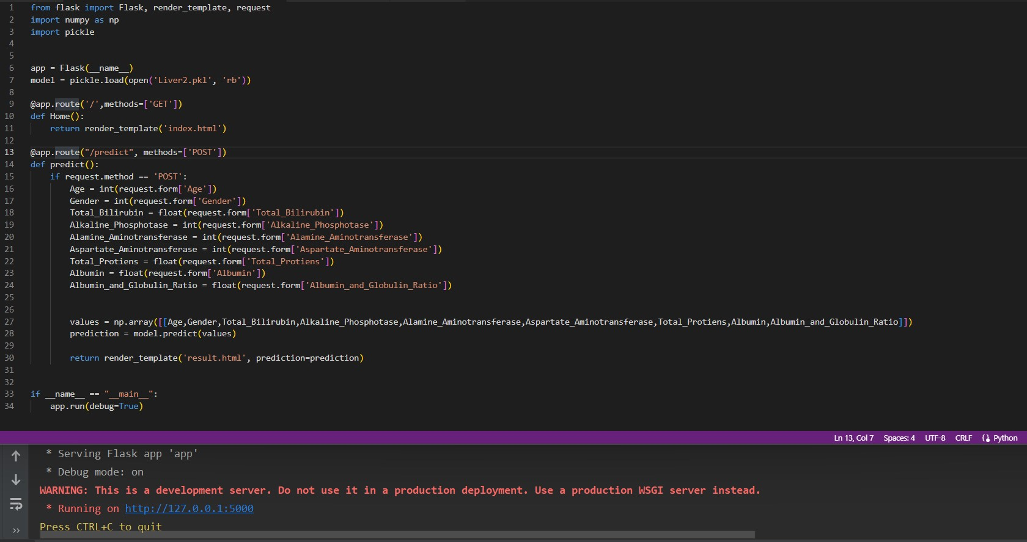

Prediction Page:

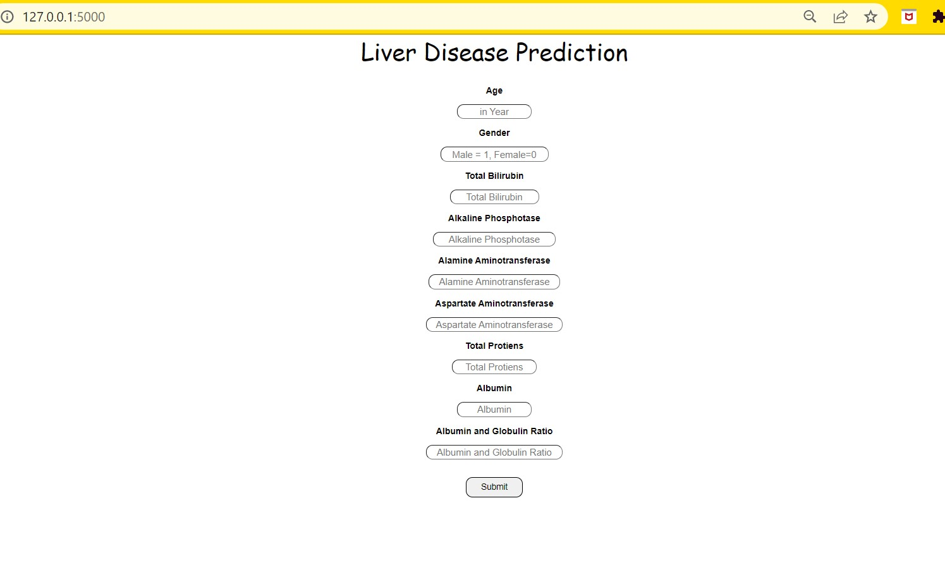

Output:

